|  |
| --- |
| **Impressive Growth & Margin Expansion**  **237% YoY Surge in Net Profits**  **Anti-Dumping Duty implemented on IPA for 5 Years** |

**Pune, India, October 29, 2024:** Deepak Fertilisers and Petrochemicals Corporation Limited, one of India’s leading producers of industrial & mining chemicals and fertilisers (“DFPCL” or the “Company”), announced its results for the quarter ended September 30, 2024.

**Consolidated Financial Highlights**

**Q2FY25 Operating EBITDA (Rs. Cr) and Margins (%)**

**Q2FY25 Operating Revenues (Rs. Cr)**

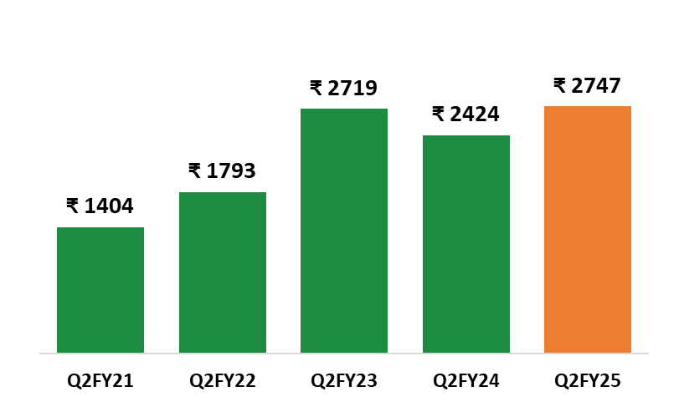 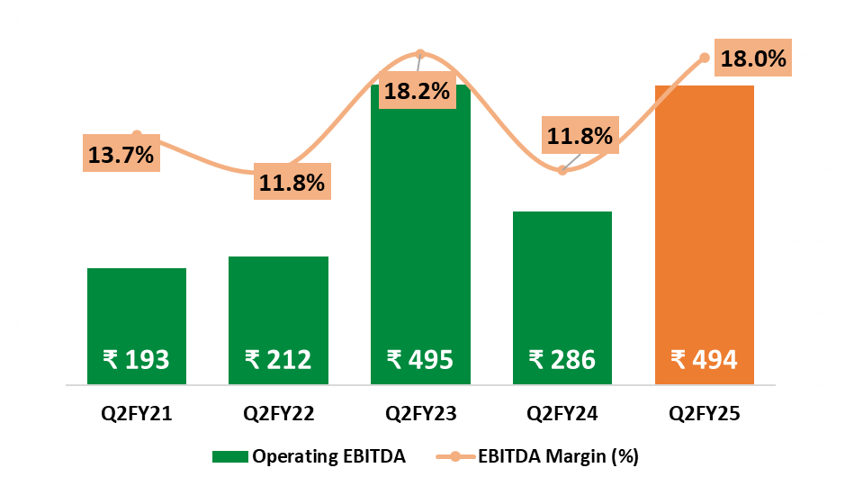

|  |  |  |  |  |  |  |  |  |
| --- | --- | --- | --- | --- | --- | --- | --- | --- |
| **Consolidated**  **(INR CR)** | **Q2FY25** | **Q2FY24\*** | **YoY Change** | **Q1FY25** | **QoQ Change** | **H1FY25** | **H1FY24** | **YoY**  **Change** |
| Operating Revenue | 2,747 | 2,424 | *13%* | 2,281 | *20%* | 5,028 | 4,737 | *6%* |
| **Operating EBITDA** | 494 | 286 | *73%* | 464 | *6%* | 959 | 567 | *69%* |
| *Margins (%)* | 18% | 12% | *619 bps* | 20% | *(237) bps* | 19% | 12% | *710 bps* |
| **Net Profit** | 214 | 63 | *237%* | 200 | *7%* | 414 | 177 | *134%* |
| *Margin (%)* | 8% | 3% | *518 bps* | 9% | *(96) bps* | 8% | 4% | *449 bps* |

*\*Q2FY24 includes the impact of NBS subsidy on channel inventories of Rs. 106 Cr and Rs.87 Cr on account of stabilization of Ammonia Plant*

|  |
| --- |
| **Key Highlights for Q2FY25:**   * **EBITDA Margin Growth**: Improved to 18% compared to 12% year-over-year. * **Record Sales Volume in Bulk Fertilizer**: Achieved an 83% year-over-year increase in sales volume of manufactured bulk fertilizer, marking the highest sales in a quarter. * **Anti-Dumping Duty Implementation**: USD 217 per metric ton Anti-Dumping Duty (ADD) on IPA for a period of 5 years. * **In-House Capture of Ammonia Price Hikes**: Increases in global ammonia prices are now fully captured internally. * **Capacity enhancement** of approximately 10% resulting from debottlenecking of the TAN plants, delivering an additional 50 KTPA and bringing the total TAN capacity volumes to 587 KTPA to support the growing needs of India’s Mining sector. * **Debt Reduction**: Prepaid ₹200 crores in debt, improving the Net Debt to EBITDA ratio from 2.66x to 1.64x. * **Change in key RM Prices in Q2FY25**: Ammonia ~11% YoY; MOP ▼ ~40% YoY; Gas ~9% YoY |
| **Chairman’s Message**  **Commenting on the performance, Mr. Sailesh C. Mehta, Chairman & Managing Director:** |
| |  | | --- | | DFPCL has shown impressive performance in Q2 FY25, achieving a 13% growth in revenue. This growth was primarily driven by the Crop Nutrition business, which experienced an 18% YoY increase in revenue, while the Chemical business grew by 8% YoY despite a lean quarter for the chemical sectors. Fertilizer and Chemical businesses acted as a natural hedge, enabling the company to deliver consistent and improved performance.  There has been a consistent increase in the proportion of revenue from specialty products, along with an overall rise in revenue, driven by the strategic move of transitioning from commodity to specialty.   * Crop Nutrition Business (CNB) achieved a remarkable 83% YoY increase in sales volume of manufactured bulk fertilizer, which is highest ever sales. * Mining Chemical: Monsoon is a lean period due to slowdown in mining activities. Accordingly, we had taken a planned shutdown of Technical Ammonium Nitrate (TAN) plant for maintenance and capacity enhancement of 50 KTPA, taking total capacity to 587 KTPA. * The Industrial Chemicals business experienced a healthy revenue growth of 9%, despite marginal decrease in volumes. This performance underscores our strategic shift from commodities to specialty chemicals, which has effectively mitigated price volatility. * The ammonia plant has enabled all our businesses to reap substantial benefits from backward integration, effectively mitigating supply chain risks and price volatility. As a result, we are now able to capture the increases in global ammonia prices within the group.   As India continues to grow, the chemical and fertilizer sectors are poised to thrive. The demand outlook for the Crop Nutrition, Mining Chemicals, and Industrial Chemicals Business is well aligned with India’s growth story, providing strong and positive tailwinds. We are actively working on the execution of the TAN Project and the Nitric Acid Project in Gopalpur and Dahej, respectively, to capitalize on future growth. | |  |     **Chemicals Review** |

* **Mining Chemicals (Technical Ammonium Nitrate):**
* In Q2 FY25, our premium product LDAN's sales volume soared by 16% YoY and rose by an impressive 20% in H1 FY25 compared to H1 FY24
* Overall sales volume was down by 21% YoY in Q2 due to a planned shutdown and lean seasons due to monsoon. The volumes were down by 1% in H1 FY25 compared to H1 FY24.
  + - Business Outlook: The mining and infrastructure is expected to pick up post monsoon as demand for Power (Coal), Cement & Steel is expected to increase thereby providing robust support for TAN demand.
* **Industrial Chemicals:**
* Nitric acid volumes was marginally down by 1% on YoY basis and up by 13% on QoQ basis.
* The specialty stainless steel grade nitric acid has received positive feedback from customers.
* IPA volumes experienced a 10% YoY decline due to process constraints and a plant shutdown. However, the recent implementation of an ADD at USD 217 per metric ton for a period of five years is anticipated to enhance both demand and pricing moving forward.
* Business Outlook: For Nitric Acid, the demand and margins are expected to be stable over the next few quarters. Propylene-based IPA demand and margins are expected to be stable and improve following the implementation of the ADD on Chinese suppliers over few quarters .

**Crop Nutrition Business (Fertilisers) Review**

* In Q2 FY25, manufactured bulk fertilizer has achieved highest ever sales volume of 268 KMT, an 83% YoY increase, driven by improved demand from above-average rains, which led to 102% Kharif crop sowing and positive market sentiment across all regions.
* Sales volume of Croptek surged to 37 KMT, reflecting a 70% YoY growth, with continued focus on providing crop-specific solutions for targeted crops, including cotton, soybean, sugarcane, corn, grapes, pomegranate, and banana.
* The company has recently launched premium water-soluble fertilizer grades.
* Sale of specialty fertilizer Bensulf was 9 KMT, up 7% YoY.
* Business Outlook: Above-normal monsoon rainfall in our core states has significantly enhanced groundwater table as well as water reservoirs for irrigation, which will help promising rabi season ahead.
* We expect the acreages under rabi cash crops to go up especially for Sugarcane, Onion, Potato etc.

**Company Overview**

**Deepak Fertilisers and Petrochemicals Corporation Ltd. (DFPCL)** is among the India’s leading manufacturers of industrial chemicals and fertilisers. With a strong presence in Technical Ammonium Nitrate (mining chemicals), Industrial Chemicals and Crop Nutrition (fertilisers), the Company supports critical sectors of the economy such as infrastructure, mining, chemicals, pharmaceutical and agriculture. DFPCL is a publicly listed, multi-product Indian conglomerate and has plants located in four states, namely Maharashtra (Taloja), Gujarat (Daher), Andhra Pradesh (Srikakulam) and Haryana (Panipat).

DFPCL is Leading manufacturer and marketer of Iso Propyl Alcohol (IPA) in India and Largest Manufacturer of Nitric Acid in Southeast Asia. The Company is developing specialised grades of Nitric acid and IPA to meet specific requirements to cater needs of the industry/consumer.

DFPCL is one of the leading manufacturers of Technical Ammonium Nitrate in the world, it is the only producer of pilled Technical Grade Ammonium Nitrate solids and medical grade Ammonium Nitrate in India. The Company has commenced best in-class Technical Services to drive downstream productivity benefits for the mining end consumers.

CNB Segment (fertilisers) offers a basket of 48 products which include bulk fertilisers, Crop nutrient solutions, specialty fertilisers, water-soluble fertilisers, bio-stimulants, micro-nutrients, and secondary nutrients, catering to every crop’s nutrient requirement. Enhanced-efficiency speciality fertilisers are developed basis rigorous R&D efforts and product trials at over 50,000 farmer demo plots. The R&D efforts have shown distinct yield and quality improvements for crops across segments such as cotton, sugarcane, onion, fruits and vegetables. Over last three years, value-added nutrition products have benefitted 6 million farmers.

|  |
| --- |
| **Deepak Fertilisers & Petrochemicals Corporation Ltd.**  Reg. Off and Corp. Off: Sai Hira, Survey No. 93, Mundhra, Pune - 411 036  *CIN: L24121MH1979PLC021360*  [www.dfpcl.com](http://www.dfpcl.com) |

**Safe Harbour:**

This document contains statements that contain “forward looking statements” including, but without limitation, statements relating to the implementation of strategic initiatives, and other statements relating Deepak Fertilisers and Petrochemicals Corporation limiter’s (DFPCL) future business developments and economic performance. While these forward looking statements are neither predictions nor guarantees of future events, circumstances or performance and are inherently subject to known and unknown risks and uncertainties, are based on management belief as well as assumptions made by and information currently available to management and only indicate our assessment and future expectations concerning the development of our business, a number of risks, uncertainties and other unknown factors could cause actual developments and results to differ materially from our expectations. These factors include, but are not limited to, general market, macro-economic, governmental and regulatory trends, movements in currency exchange and interest rates, competitive pressures, technological developments, changes in the financial conditions of third parties dealing with us, legislative developments, and other key factors that could affect our business and financial performance. DFPCL undertakes no obligation to publicly revise any forward-looking statements to reflect future / likely events or circumstances.